Seton Hall University
BACC2103
Fall 2018

Financial Accounting Project

In this project, you will use your understanding of financial accounting to prepare an analysis of a real company's financial statements. To prepare your analysis, you will use Microsoft Excel and data from the internet. Then, you will communicate the results of your analysis in a written report and an oral presentation. Thus, this project will help you build your critical thinking, technology, and communication skills.

This project is a required component of BACC2103, Financial Accounting. In order to receive a passing grade in the course, you must complete and submit the entire project.

Part 1 – Spreadsheet (25 points) Due Monday, October 22nd at 3 pm.
[10% deduction if late with an additional 10% for each week thereafter.]
A. Obtain audited financial statements.
B. Download the spreadsheet template.
C. Download the applicable financial statements and copy into the appropriate tabs within the spreadsheet template (see separate instructions in Appendix A).
D. Prepare the condensed financial statements by linking cells between the Summary tab and the downloaded financial statement tabs. DO NOT KEY THE BALANCES INTO THE TEMPLATE TAB! Points will be deducted if you do so.
E. Prepare condensed common-sized statements and condensed trend analyses by using formulas that reference to the appropriate cells within the condensed financial statement sections, all within the Summary tab. DO NOT CALCULATE OFF-LINE AND KEY THE RESULTS INTO THE CELLS! Points will be deducted if you do so.

Part 2 – Spreadsheet (Continued) Due Monday, November 5th at 3 pm.
[10% deduction if late with an additional 10% for each week thereafter.]
A. Compute financial ratios and the DuPont Analysis of ROE.
B. Obtain industry average ratios

Part 3 – Written Report (50 points) Due Monday, November 19th at 3 pm.
[10% deduction if late with an additional 10% for each week thereafter.]
Prepare a written report about your company.

Part 4 – Presentation (25 points) Dates to be set by instructor.
[Presentations must be performed on the scheduled date.
THERE WILL BE NO MAKE UP FOR PART 4.]
Prepare and deliver an oral presentation.

Part 1 – Spreadsheet

A. Obtain Audited Financial Statements
For your assigned company, obtain a copy of the most recent annual financial statements to be found in its Annual Report or in SEC Form 10-K. Look for your company’s 10-K on the Securities and Exchange Commission website at http://www.sec.gov/edgar/searchedgar/companysearch.html . Following the instructions in Appendix A. Use annual financial statements (SEC Form 10-K), not quarterly reports (SEC Form 10-Q) . Do not use summary financial data provided by an intermediate such as Google, Yahoo!, or MoneyCentral.

Because the most recent financial statements will only show a balance sheet for two years you will need to obtain the third year (.i.e., the earliest year) by downloading the previous year's financial statements (10-K). You do not need to do this for the income statement or cash flow statement as three years are presented in the most recent financial statements.

Print out the Balance Sheet (from current and previous year’s financial statements), Income Statement, Statement of Cash Flows, and Statement of Changes in Stockholders’ Equity (form the current year only). Be careful to include earnings per share with the Income Statement. Some companies use different names for these statements. Save paper: print out only the financial statements and not the entire 10-K. However, you should download the entire report and save as a PDF file because you will need to refer to this report when analyzing your company and preparing your paper.

B. Download the spreadsheet template
1. Download the spreadsheet template from your course's Blackboard website. Name it with your last name followed by your company name (i.e. “Doe Starbucks.xlsx”).
2. Open the template in Microsoft Excel. Provide your name as the user by clicking on Tools, then Options. Click on the General tab. Enter your name in the space provided for User Name. Then click OK. If you change computers, then redo this step.
3. Complete the Cover Page sheet by inputting in the appropriate cells (as highlighted in green) the name of your company, ticker, current/prior/base yearend dates, your name and submission date.

C. Copy downloaded financial statements into spreadsheet template
See Appendix A.

D. Prepare the condensed financial statements
In the cell-protected Summary sheet, you can only edit cells shaded green or red.

Linking to cells from the audited financial statements that you copied into your spreadsheet template, prepare the Condensed Balance Sheet, Condensed Income Statement, and Condensed Statement of Cash Flows. DO NOT KEY BALANCES INTO THE CONDENSED FINANCIAL STATEMENT CELLS! Points will be deducted if you do so.

Use good spreadsheet technique, as described in the Stillman guidelines. You can copy and paste, but DO NOT CUT AND PASTE!!!! It will cause the edit-checks to give you a false reading.

E. Prepare condensed common-sized statements and condensed trend analyses
Use Microsoft Excel formulas that link within the Summary sheet to compute all trend and common-sized calculations. DO NOT CALCULATE OFF-LINE AND KEY THE RESULTS INTO THE CELLS! Points will be deducted if you do so.

Prepare three years of condensed common-sized financial statements for the Balance Sheet and Income Statement. Also prepare a three-year trend analysis using the earliest year as the base year for the condensed Balance Sheet and condensed Income Statement.

Part 1 – Spreadsheet Submission Requirements Monday, October 22nd at 3 pm.
- Upload your completed Part 1 - Spreadsheet to BlackBoard.
- Submit the following printed material in class:
  - A printout of all pages of your Part 1 - Spreadsheet
  - A copy of the audited financial statements (not the whole 10-K’s)

Keep a copy of these documents because you will need them to finish the project.

Spreadsheets will be graded based on the accuracy of your computations, proper use of formulas, and professional appearance. Late or incompletely submitted assignments will be penalized 10%, with an additional 10% for each week thereafter.

Part 2 – Spreadsheet

A. Compute Financial Ratios and the DuPont Analysis of ROE
In the Summary sheet, use Microsoft Excel formulas to compute the financial statement ratios. Use the ratio formulas provided in the Formula INFO, referencing other cells in the Condensed Financial Statement sections of the Summary sheet, and if necessary some figures in the applicable financial statement tabs that you downloaded from the SEC website. Use good spreadsheet technique, as described in the Stillman guidelines. DO NOT CALCULATE OFF-LINE AND KEY THE RESULTS INTO THE CELLS! Points will be deducted if you do so.

Compute ratios for the two most recent fiscal years. Next, in the Change column, choose the answer that best describes the change in each ratio from the prior year to the current year.

Use formulas to complete the DuPont Analysis of ROE.

B. Obtain industry average ratios

Find industry ratio information at www.msn.com/money, following these steps:
- Below the picture covering current events is a search box with words Quote Search.

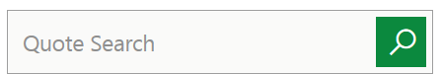

Within this box, type the name of your company. The “ticker,” (a one to four letter identifier, such as AAPL for Apple Inc.), along with your company’s name will begin to appear.
- Select your company’s name. The latest stock quote along with the graph presenting the stock price movement for your company will appear on your screen. In between the quote and graph is a menu bar with the SUMMARY item highlighted. Select the menu item ANALYSIS.

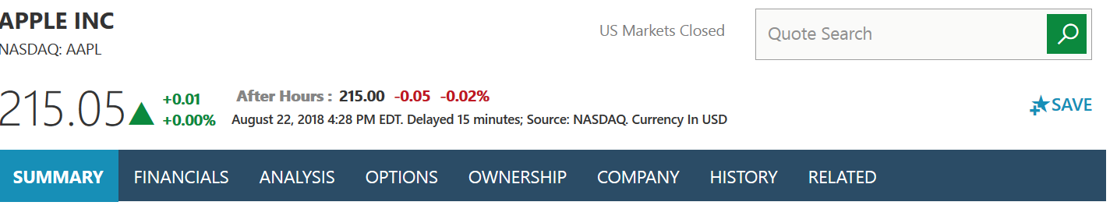

- Scroll down until you come to a second menu bar with the option FINANCIAL HEALTH, TRADING STATISTICS, MANAGEMENT EFFECTIVENESS. The option FINANCIAL HEALTH will be highlighted. Right below this menu bar is the title of your industry. To the right are several ratios you will be looking for. The last column covers those related to your industry. Note: When you zoom the screen out and in, this website provides more or less information. If you cannot find all of the ratios that you are looking for, try zooming the screen out (to 70% or less). Additional ratios may appear.

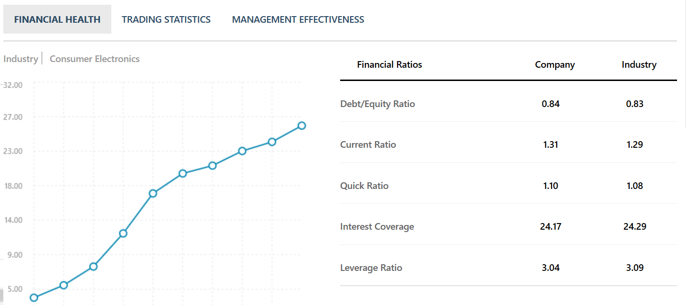

- Next select from this menu bar, the third option MANAGEMENT EFFECTIVENESS. The remaining industry ratios will appear.

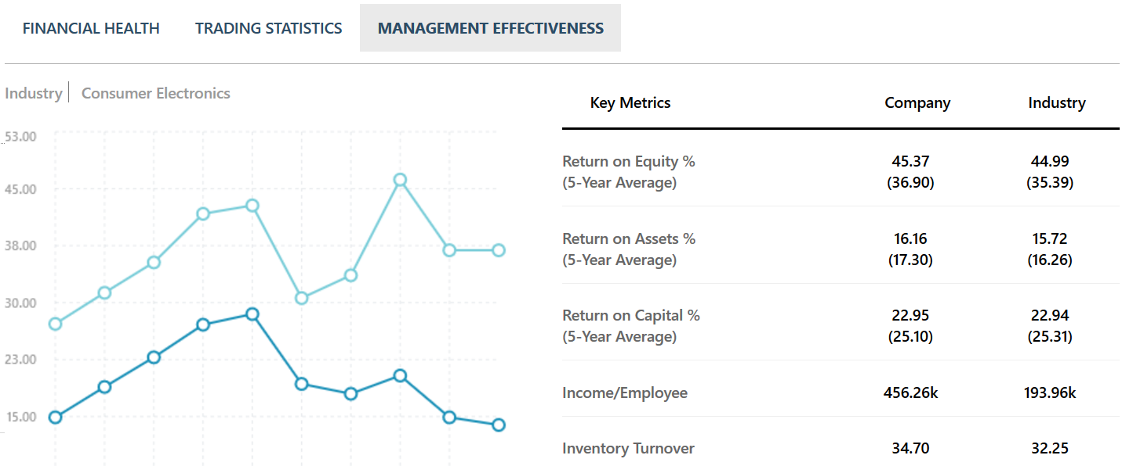

You may not find the following industry ratios: (i) Return on sales (ROS), and (ii) Debt ratio msn.com/money website. If that is the case, you should look to other sources such as Yahoo, Bloomberg, etc.

Part 2 – Spreadsheet Submission Requirements Due Monday, November 5th at 3 pm.
- Submit your completed Spreadsheet using the Assignment function in BlackBoard.
- Submit the following printed material in class:
  - A printout of all pages of your spreadsheet
  - A copy of the audited financial statements

Keep a copy of these documents. You will need them to finish the project.

Spreadsheets will be graded based on the accuracy of your computations, proper use of formulas, and professional appearance. Late or incompletely submitted assignments will be penalized 10% with an additional 10% for each week thereafter.

Part 3 – Written Report

Prepare a Written Report
Write a 4 to 6 page report addressing each of the following questions about your company:

- How does your company make money? What industry is your company in? What are some of your company’s competitors? What makes your company stand out from its competitors?
- How profitable is your company? Why? Your explanations should refer to the appropriate financial ratios and what is driving the changes when comparing to prior years, to the industry, to competitor’s results.
- How liquid is your company? Which financial statement ratios help explain your company’s liquidity?
- How solvent is your company? How does debt leverage help or hinder your company? Do you believe that the company should have more or less debt?
- How efficient is your company? Refer to the appropriate ratios that support your discussion.
- What risks does your company face? What could go wrong, and what are your assessments of the likelihood of these risks? A review of the company’s Annual Report should provide you with the need information for this discussion.
- Name at least one ethical issues related to your company. Describe social benefits or possible negative risks associated with this issue. How might this issue impact your financial analysis?
- What is your overall assessment of your company as an investment? Would you invest in it? Support your answer based on your answers to the above questions.

Organization. Your report should be organized in a logical manner. Please do not use the above questions as a basis for a question/answer format. In addition, do not describe the formulas for the various ratios, but discuss the drivers behind the balances used in these formulas.

Professional Quality. Prepare your report as a professional-looking document for which you were paid a great deal of money. Be careful with grammar and spelling; business leaders have a zero tolerance policy regarding basic spelling and grammar mistakes. Use Microsoft Word, double-space the type, and leave one-inch margins.

Proper Referencing. Copying or rewording another report without proper citation and quotation is considered to be plagiarism. In the body of the paper, include proper references to all written materials and internet sources, with a complete page of sources used.

Before Monday, November 19th at 3 pm, submit a digital copy of the written report using the Assignment function in BlackBoard.

Written reports will be graded based on the comprehensive coverage and accuracy of your analysis, use of a clear and concise writing style that is easy to understand, and professional appearance. Tables, graphs, charts may be provided, but are not consider as part of the 4 to 6 page requirement. Late or incompletely submitted reports will be penalized by 10%with an additional 10% for each week thereafter.

Part 4 – Presentation

Prepare and deliver an oral presentation.
Using PowerPoint, prepare a five to seven-minute professional presentation about your company. Your presentation should include the following:
- A brief description of the company, its products, its market, and its competitors.
- Several innovative or unusual things about your company.
- Key financial ratios. Do not simply list all ratios. Instead, focus on the ratios that are important for your specific company and factors that you used to arrive at your overall conclusion.
- May provide no more than two graphs that help support your conclusion.
- Your overall conclusion about investing in the assigned company.

You will be expected to answer questions from the audience.

Please wear "business casual” or nicer attire.

Grades will be based on your professional demeanor, the organization of your presentation, presentation skills demonstrated, and on the effective use of PowerPoint.

Submit PowerPoint slides to your instructor via BlackBoard at least 24 hours before your scheduled presentation. On the day of presentation bring a hard-copy of your PowerPoint slides (six slides per page) for your professor. There will only be one scheduled day for these presentations. NO MAKE UP SESSIONS WILL BE HELD!

Appendix A

Steps for Downloading Financial Statements from SEC.GOV Website
Screenshots and step-by-step instructions below for easy access to Form 10-K’s automatically downloaded into excel for you directly from the SEC’s (Security and Exchange Commission) website.
Step 1: Log into www.sec.gov

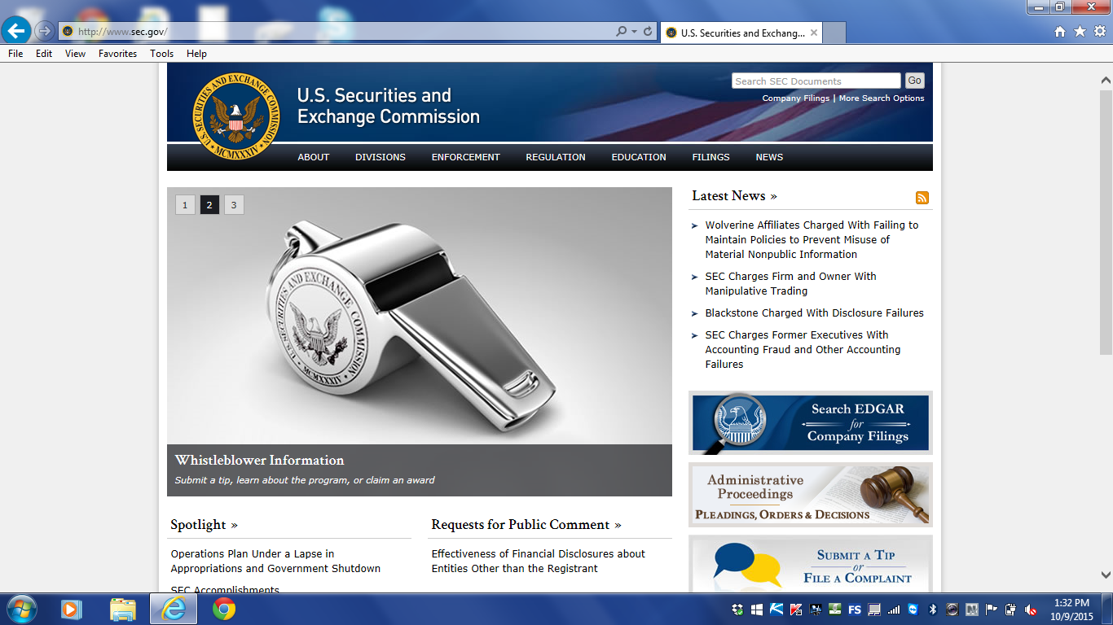

Step 2: Click on “Filings” – “Company Search Filings”

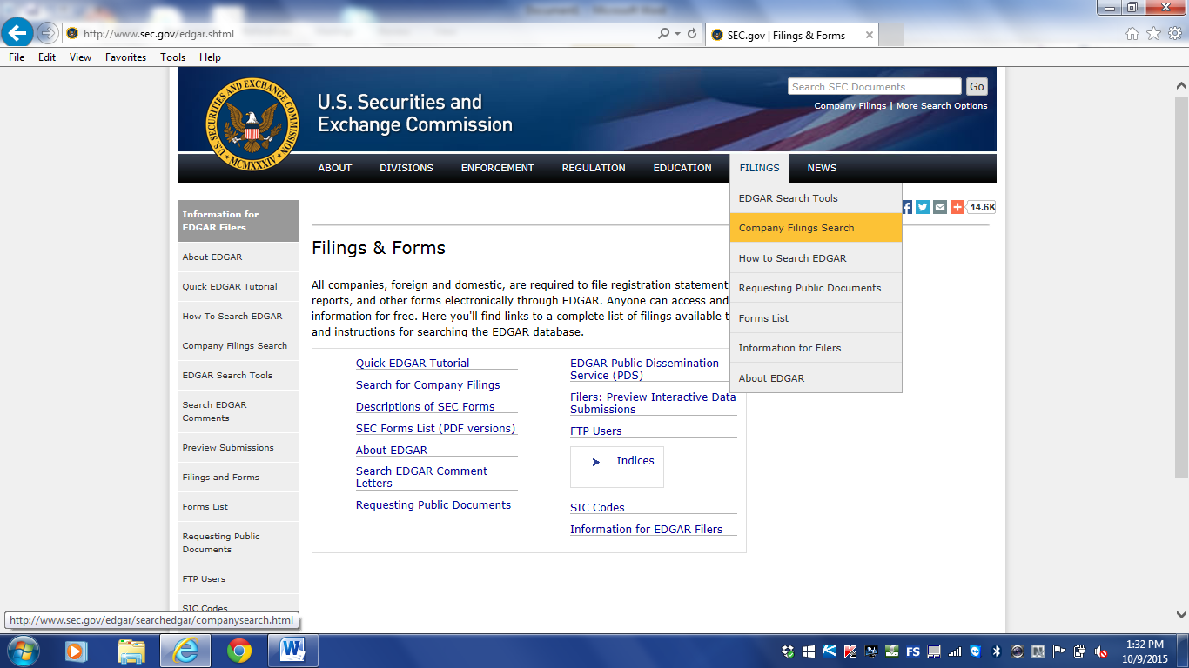

Step 3: Enter your company’s Ticker Symbol under “Fast Search”
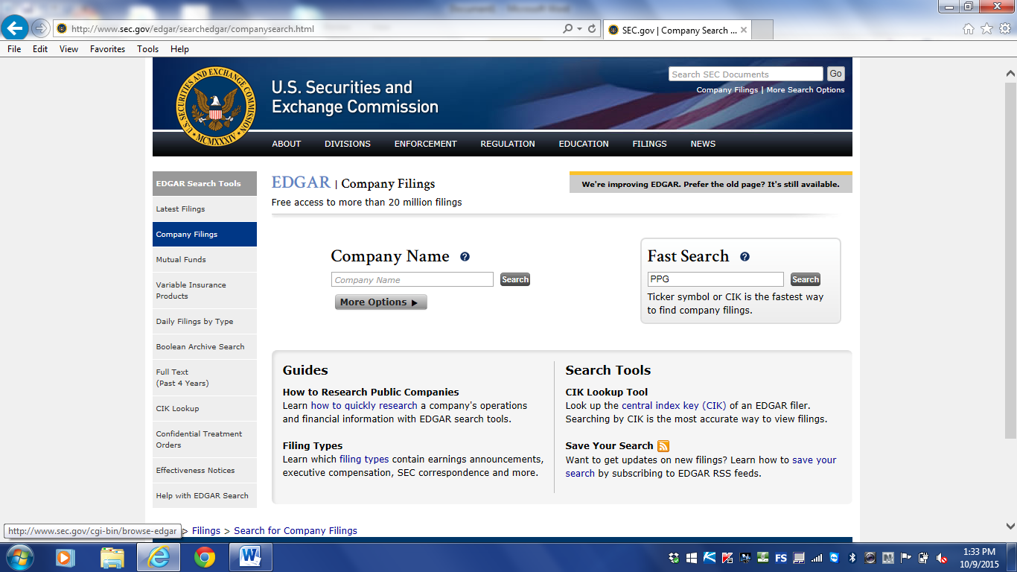

Step 4: Locate Form 10-K. Click on button for “interactive data”. (You will need to get the two latest years Form 10-K’s).

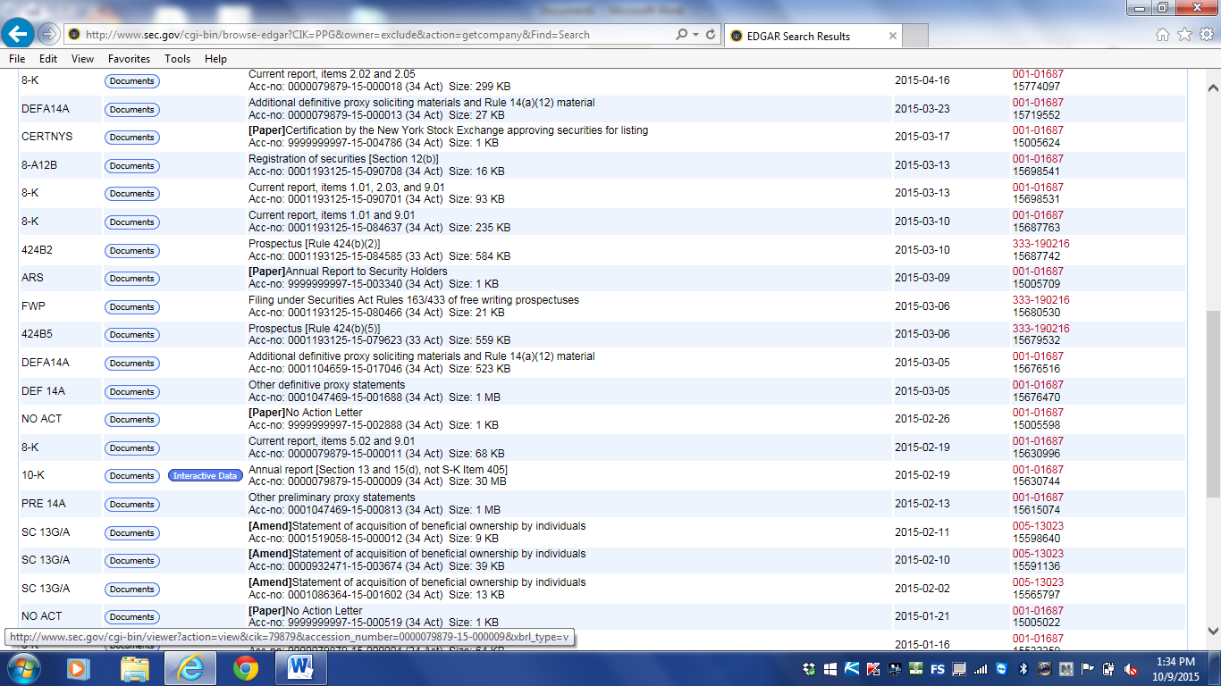

Step 5: Click link to “View Excel Document”.

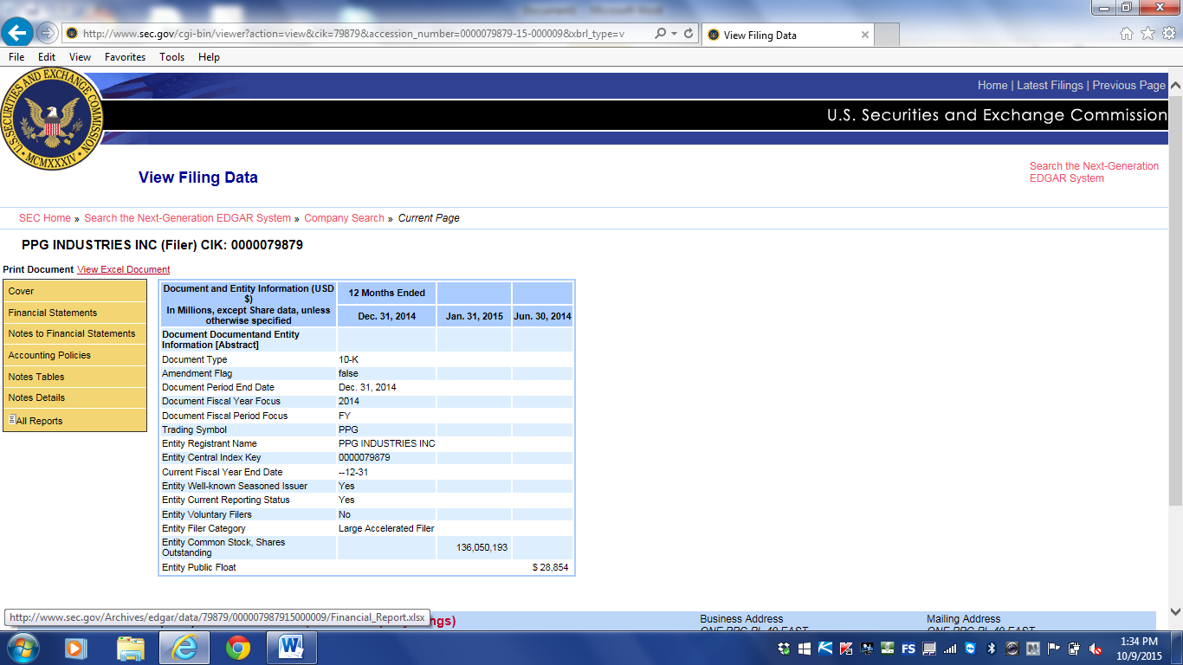

Step 6: Chose “open file” option and the file with the company financial statements will open. Save this file to your computer.

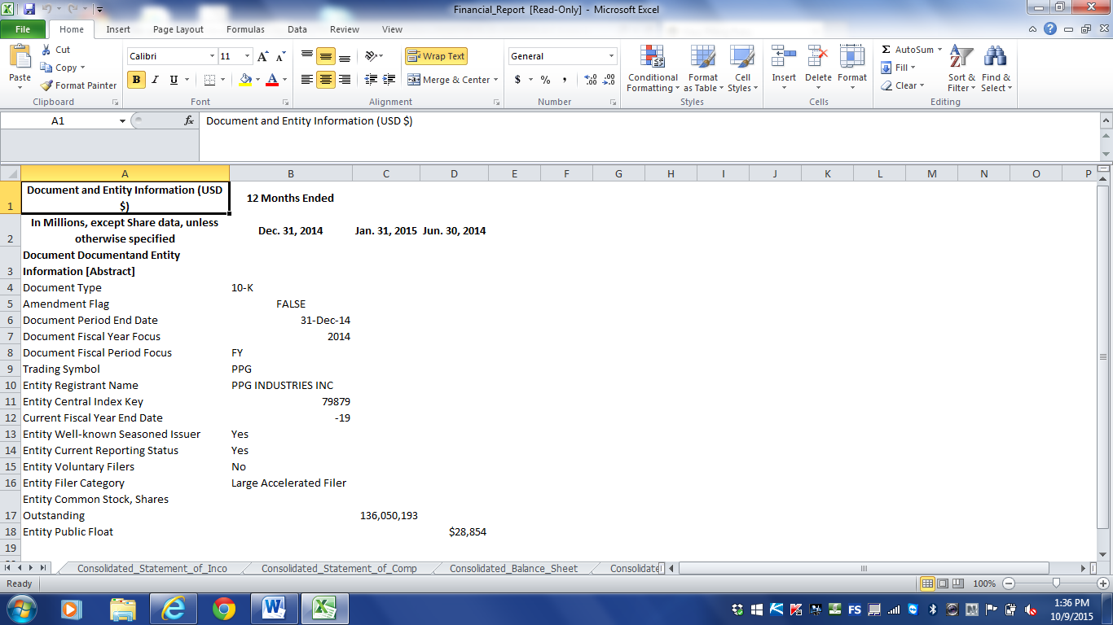

Step 7: For Part 1 of the project, copy the balance sheet tab into the “Project Spreadsheet Fall 2015” with I gave to you via Blackboard.

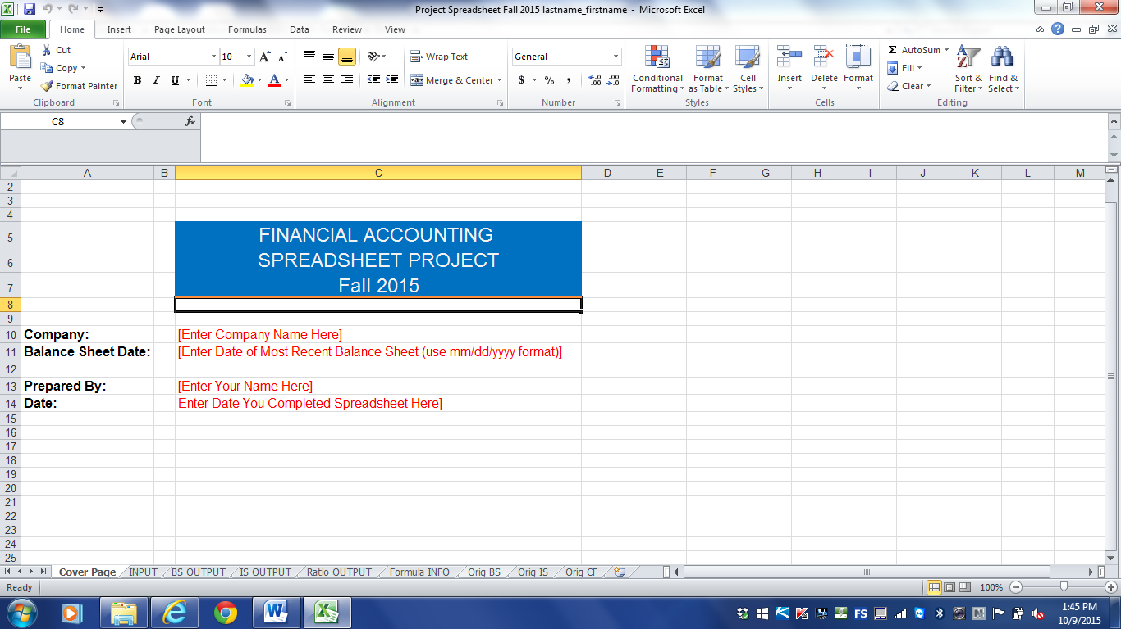

Step 8: Instead of simply typing the numbers in for the project, please link to the Balance Sheet tab(s) that you copied into the Project file (see example below). This is very good practice and is what is done in the business world. This allows you to easily check your work and allows the person reviewing your work the ability to see where you got your numbers from.

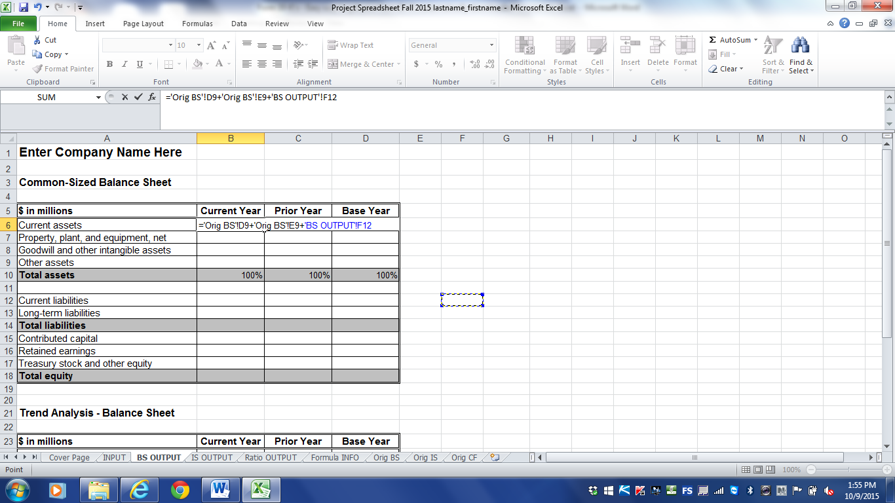

You may find the following YouTube video helpful in performing Part 1, including the download form the SEC.GOV website: https://www.youtube.com/watch?to%2Ce_cpmtomie=3&v=rh9PhfiERQM

